**LINUX DISK MANAGEMENT**

File System:

* File System is a method to store and organize files and directories on disk.
* A file system can have different formats called file system types.
* These formats determine how the information is stored as files and directories.

Windows file system

====================

FAT

FAT32

NTFS

Linux file system

====================

ext1

ext2

ext3

ext4 - Default file system in RHEL/OEL- 6

XFS - Default filesystem in RHEL/OEL - 7/8/9

First we should see default disk created

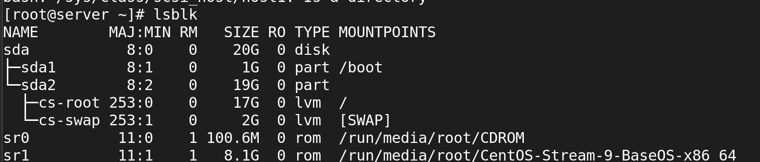

**Creating a new disk**

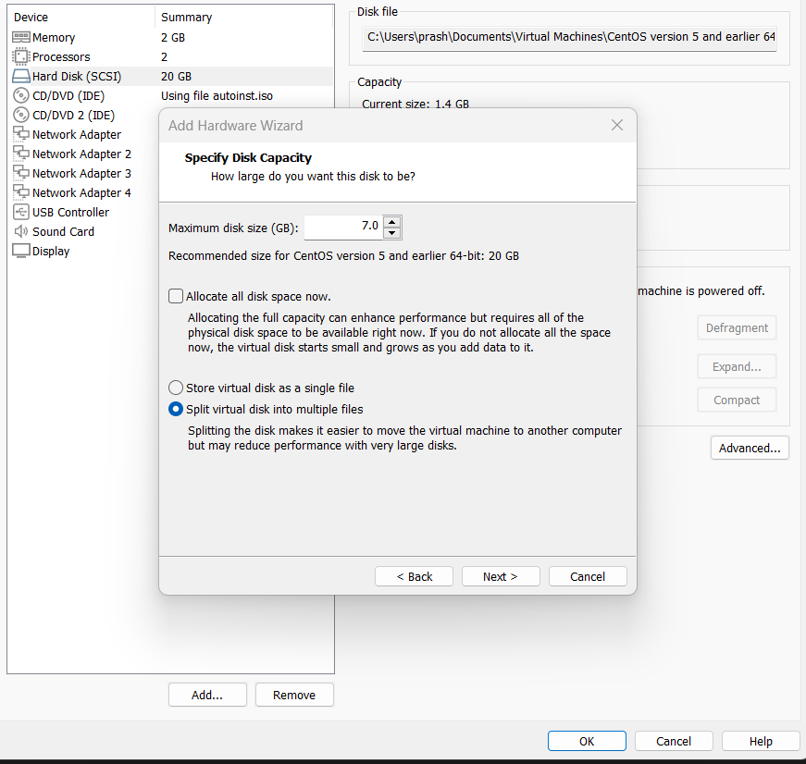

After creating a new disk now u should scan disk by using command:

# echo '- - -' > /sys/class/scsi_host/host0/scan

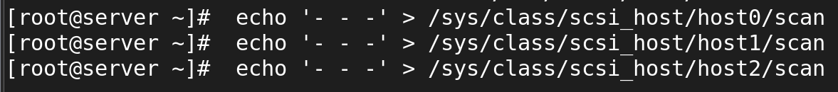

**Now we should list the disk using command lsblk**

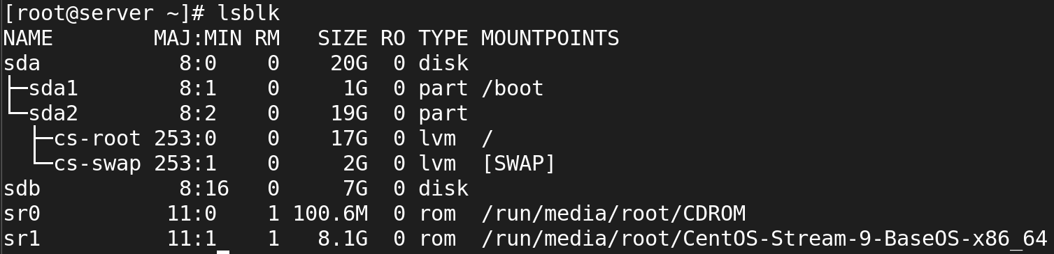

Set a file system for the newly created disk:

**# mkfs.xfs /dev/sdb**

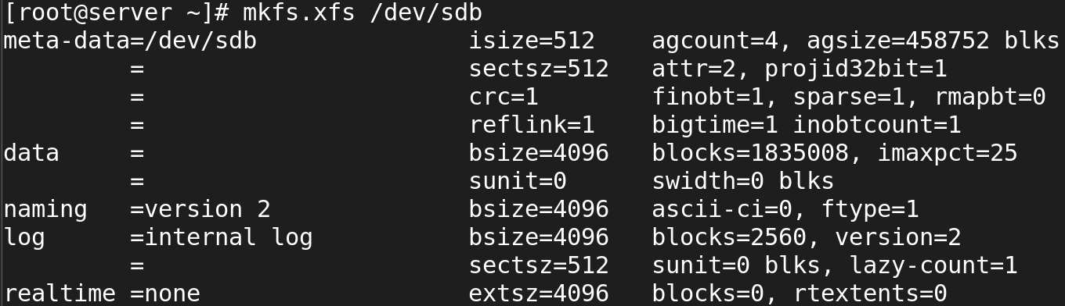

Now u should mount a newly created disk by an new dir name

# mount /dev/sdb /<dir name>

To check mounted or not:

**# df -Th**

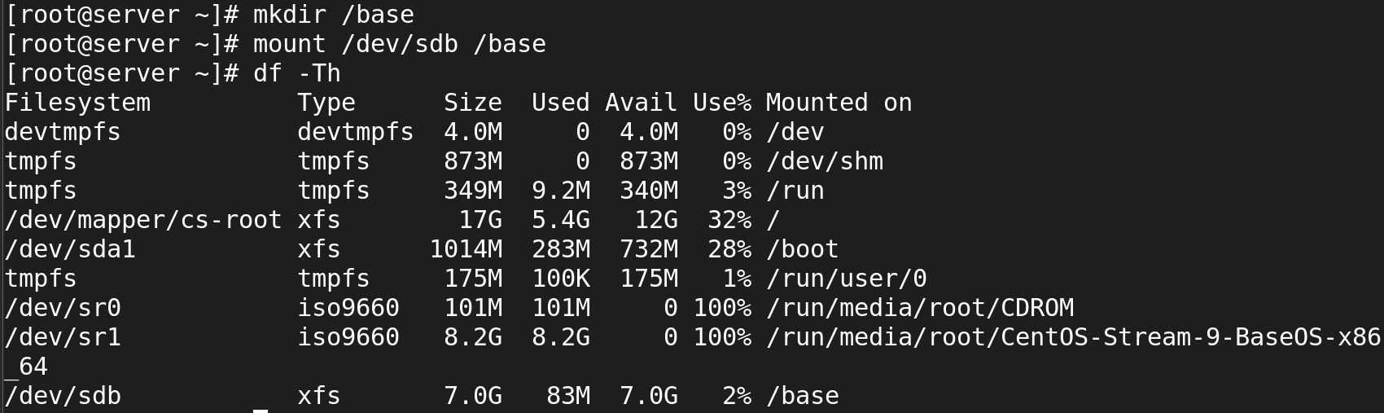

Now u create a files in an mounted dirctery

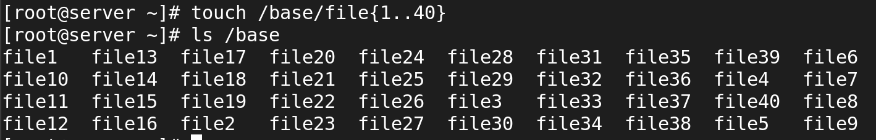

It a type of temporary mount after we reboot the system it automatically disappeare the mounted directory

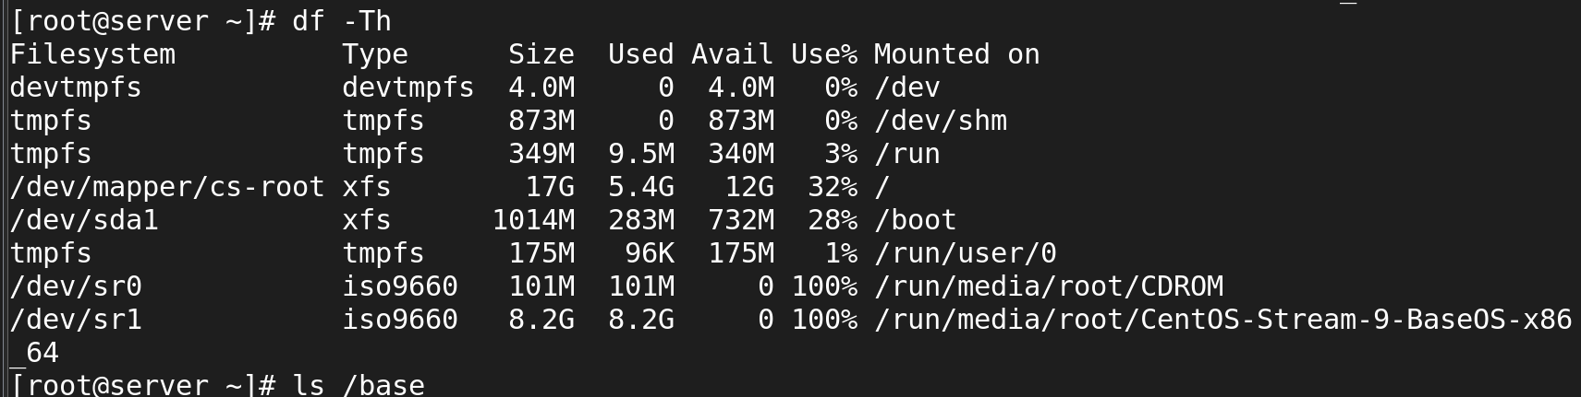

For permanent mount

Add fstab entry:

**# vi /etc/fstab**

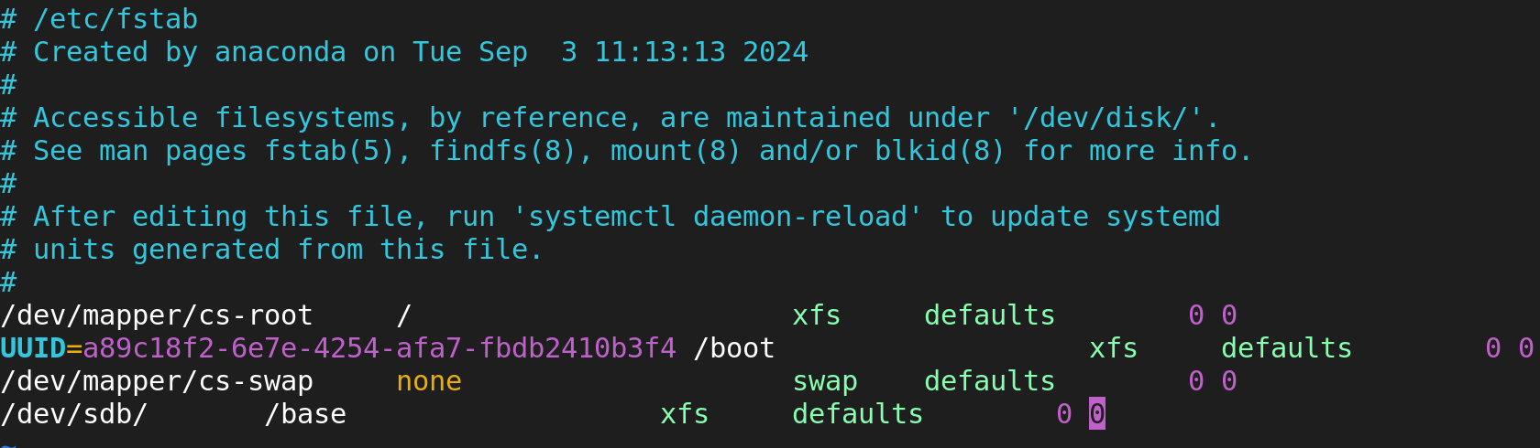



Partition Table:

* Partition can be considered as a piece of disk space.A partition table is a partition of a disk that contains

The two most popular partition tables:

* Master Boot Record (MBR) partition
* GUID Partition Table (GPT) partition

MBR (dos) partition:

We can create max 4 partition

* 3 primary
* 1 Extended

GPT partition:

we can create 128 partition

**To create file system with partition**

**Create new disk:**

selete VM ---> setting ---> attach disk

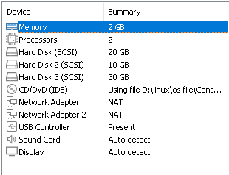

**scan disk**

* echo '- - -' > /sys/class/scsi_host/host0/scan



**To check disk is shown:**

* lsblk

sdb – new disk

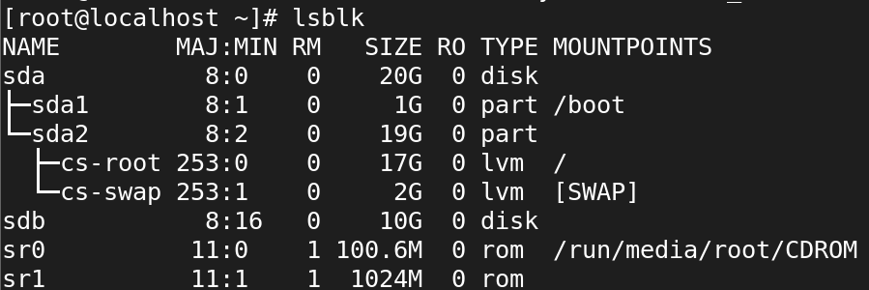

1. **Commands to create partition:**

* fdisk <disk name>

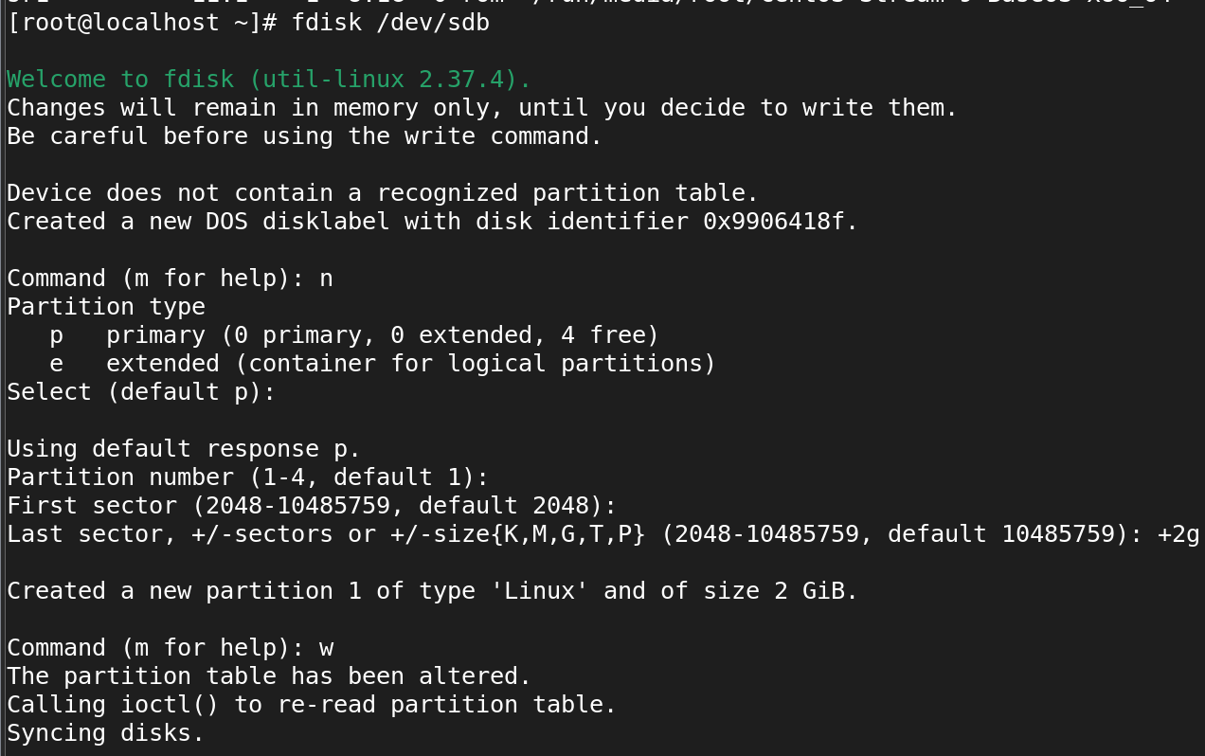

1. **To check partition is created or not:**

* lsblk

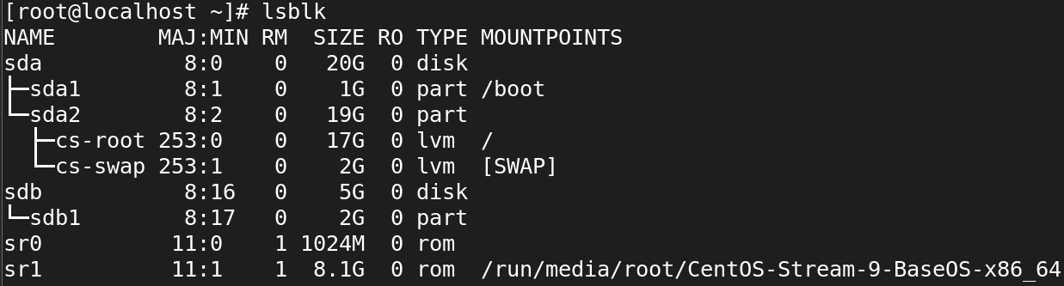

Now we was extended the remaining 3gb

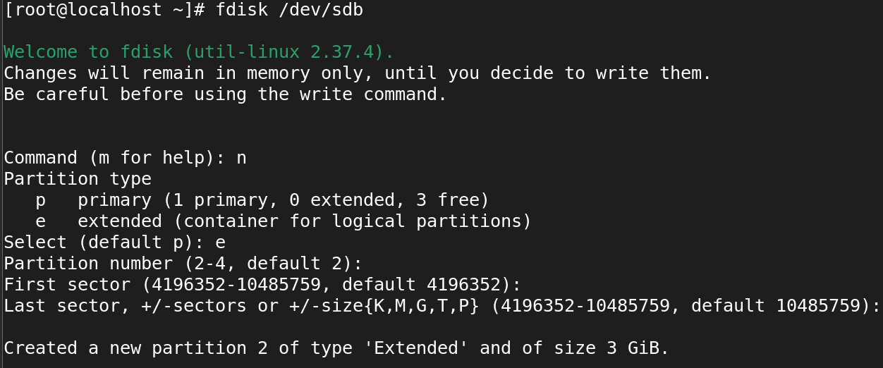

1. **To make file system with 1 partition:**

* mkfs.xfs /dev/sdc

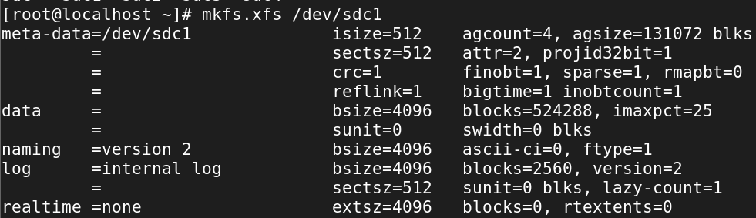

1. **Mount the directory:**

* mount /dev/sdc1 /devaki



1. **Check whether is mounted or not:**

* df -Th

